JSNN Chemical Hygiene Plan (CHP)

General
The JSNN Chemical Hygiene Plan (CHP) is intended to assist faculty, staff, and students with the OSHA 29 CR 1910 requirements for working in research laboratories. CHP document in conjunction with the lab specific Safety Plan shall satisfy the requirements for the OSHA Chemical Hygiene Plan. This document shall be reviewed and used by all researchers as a safety reference and required training. The CHP also informs employees of their rights and obligations under federal regulations regarding laboratory use of hazardous chemicals.
While the scope of this document is limited to hazardous chemicals, additional information regarding JSNN health and safety requirements for other types of hazards, including but not limited to ionizing and non-ionizing radiation, biohazards, and the safe use of hazardous materials and equipment can be found on the JSNN Website.

Scope

What is the CHP?
The Chemical Hygiene Plan applies to all JSNN research personnel, who handle or may be exposed to hazardous chemicals in research laboratories. The Chemical Hygiene Plan is in place to inform employees about specific health hazards found in laboratories and to reduce chemical exposures below limits specified by OSHA. The Chemical Hygiene Plan shall be readily available to all laboratory employees at all times. The CHP shall include all elements required by OSHA 29 CFR 1910.1450.

c) What is not covered
The CHP does not cover work with radioactive materials or biological agents. Please visit JSNN Website for more information on other safety subjects that are not covered under CHP.

d) Chemical Hygiene Officer (CHO)
The principal investigator (PI) or his/her designated person must serve as the chemical hygiene officer to coordinate and implement the CHP in their area. ROEHS University Chemical Hygiene Officer serves as the JSNN CHO

The basic safety training and information you need

The minimum safety training for working at JSNN research labs include:
- Lab safety training
- Hazardous waste training
- Nanomaterials safety training
- Additional subject-specific training is required based on the job description, including:
  - Biological safety
  - Bloodborne pathogen safety
  - Fume Hood safety
  - X-ray safety or X-ray awareness safety
  - Autoclave safety
  - Cryogenic safety
  - Laser safety
  - Respiratory protection
  - In addition, researchers must review content of this document as part of their required safety training, align with their lab safety plan, internal SOPs, and any other equipment-specific or process-specific training provided by PI

OSHA Laboratory Safety Standard requires that employee information and training shall cover the following elements:
- Contents of the OSHA Laboratory Safety Standard (29 CFR 1910.1450)
- The location and availability of the Chemical Hygiene Plan (this document)
- The permissible exposure limits for OSHA regulated substances (29 CFR part 1910, subpart Z) or recommended exposure limits for other hazardous chemicals where there is no applicable OSHA standard
- Signs and symptoms of exposure
- Location and availability of known reference material on the hazards, safe handling, storage and disposal of hazardous chemicals found in the laboratory
- Methods that may be used to detect presence of hazardous material in the work environment, include but are not limited to gas, dust and fume monitoring equipment or procedures. Please contact ROEHS for any necessary monitoring / sampling for hazardous material.
- Employees need to be informed about the specific health and physical hazards of the chemicals in their work environment. SDS and OSHA Occupational Health and Safety Standards are two major sources for this information.
- The measures employees can take to protect themselves from these hazards, including specific procedures the PI / Supervisor has implemented to protect employees from exposure to hazardous chemicals, such as appropriate work practices, emergency procedures, and personal protective equipment are to be used.
- Safety training for specific hazards / procedures such as safe handling of pyrophoric chemicals or perchloric acid use.

 | Supplementary Modules:
• | Safety in Academic Chemistry Laboratories
• | “Prudent Practices in the Laboratory: Handling and Disposal of Chemicals”

4) Laboratory specific: Standard Operating Procedures (SOP’s)
As part of the Safety Plan, laboratories need to develop standard operating procedures, which spell out each experiment, along with all safety precautions, necessary protective methods and equipment. SOPs need to be updated frequently and be readily available for employees to use.

5) Medical consultation and examination
Employees working with animals or respirators are required to complete a health questionnaire, which is reviewed by an occupational physician working for or with University. The questionnaire review will allow for appropriate medical recommendations to be provided to the employee and their supervisor for the work they will be performing. Medical examinations may be required for certain other employee tasks. In the event of an overexposure to a toxic substance, the emergency phone number for the university should be called (911). As part of the responding action employees may be offered the opportunity for a medical exam or consultation related to their exposure.

6) Recordkeeping
The PI / Supervisor should maintain records of all relevant training that employees or students receive before, or during their tenure in the research lab. Where medical exams are provided, the healthcare provider will establish and maintain, for each employee, an accurate record of medical consultation and examinations including tests or written opinions required by OSHA. ROHS will maintain an accurate record of any measurements taken to monitor employee exposure to hazardous materials.

7) Labeling

Globally Harmonized System (GHS)
The Globally Harmonized System of Classification and Labeling of Chemicals (GHS) is an international system for standardizing and harmonizing the classification and labeling of chemicals. It is a logical and comprehensive approach to:
- Defining health, physical and environmental hazards of chemicals;
- Creating classification processes that use available data on chemicals for comparison with the defined hazard criteria; and
- Communicating hazard information, as well as protective measures, on labels and Safety Data Sheets (SDS).

OSHA Hazard Communication Standard (HCS) (29 CFR 1910.1200) and GHS
HCS is one the major existing standards which is harmonized by the GHS. Changes in the HCS affect many other standards such as the Lab Safety Standard (29 CFR 1910.1450). In the GHS system, the term ‘Physical and Health Hazard Classification’ is used to indicate that only the intrinsic hazardous properties of substances and mixtures are considered .In GHS classification system for hazards a higher number on the classification scale indicates a lower hazard. GHS labeling includes the following nine pictograms:
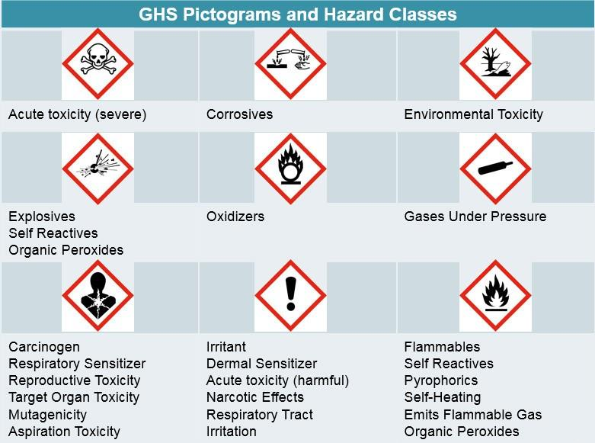

Labeling on chemical containers includes:
- Symbols (hazard pictograms): Convey health, physical and environmental hazard information, assigned to a GHS hazard class and category.
- Signal Words: "Danger" or "Warning" are used to emphasize hazards and indicate the relative level of severity of the hazard, assigned to a GHS hazard class and category.
- Hazard Statements
After the signal word, hazard statements will appear, describing the specific hazard of the material (e.g. avoid skin contact). Below is an example of a GHS-compliance label:
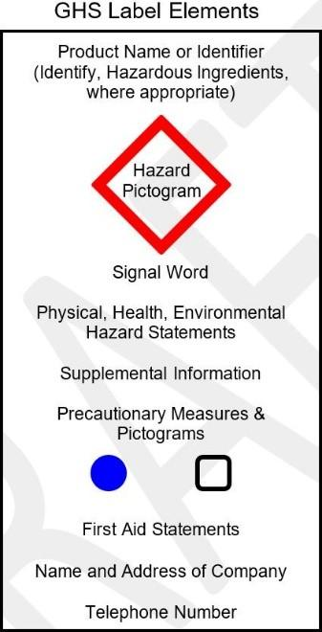

 | Supplementary Modules:
• | A Guide to The Globally Harmonized System of Classification and Labeling of Chemicals (GHS)
• | HCS / HazCom 2012 Final Rule & Appendices

8) Hazard determination / identification and assessment

Adequate facility for chemical use
Before starting new research or modifying existing research protocols, the PI / Supervisor needs to ensure that there are adequate facilities in place based on the type / classes of hazardous materials used. This includes, but is not limited to; eyewashes, safety showers, laboratory chemical hoods, gas cabinets, glove boxes, storage cabinets, gas detectors, fire detection / extinguishing systems, etc.

i) Eyewash stations

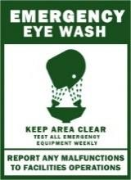
Eyewash stations are required for all laboratories utilizing chemicals that are hazardous to human eyes. Eyewashes are considered a first aid measure rather than a preventative measure. Proper exposure control methods, including eye protection are always required to minimize eye exposure to hazardous chemicals. Emergency eyewash stations need proper care and maintenance in order to provide adequate protection to laboratory workers. PI / supervisors need to train all students / employees on the location and proper use of eyewash stations. Labs are responsible for weekly eyewash tests and documenting the test in a log sheet. Any deficiencies must be reported to ROEHS

ii) Safety showers
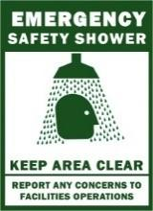
Safety showers are required whenever the body may be exposed to injurious corrosive chemicals or any chemical hazardous to human skin. Safety showers are considered a first aid measure rather than a preventative measure. Proper exposure control methods, including face, hand, and body protection must be utilized to minimize skin exposure to hazardous chemicals. Safety showers need proper care and maintenance in order to provide adequate protection to laboratory workers. PI / supervisors need to train all students / employees on the location and proper use of
safety showers. ROEHS is responsible for testing safety shoes on a bi-annual schedule.
Emergency safety showers and eyewash installations must meet the ANSI Z358.1 guidelines for plumbed and self-contained eyewash and safety showers and must not be obstructed by equipment/objects.

Adequate engineering controls
The PI / SUPERVISOR shall ensure that the type and number of the engineering control devices and exhaust systems are appropriate for new or modified laboratories.

Change and modifications
Any change in laboratory systems, such as change of application, adding new eyewash / showers, and adding or removing local exhaust systems, requires review and approval

9. Classes of chemical hazards: (Health and physical hazards)
For proper storage and exposure prevention purposes, PI / supervisor need to be aware of different classes of chemical hazards. All hazardous chemicals shall be used in exhausted enclosures such as laboratory chemical hoods.
 | Supplementary Module:
• | OSHA 29 CFR 1910.1200 App A: Health Hazard Definitions

Acutely toxic agents :
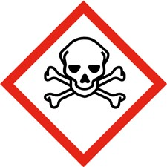
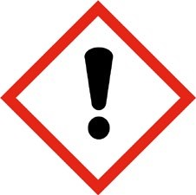
OSHA regulations (29 CFR 1910.1200 Appendix A) defines: Acute toxicity as those adverse effects occurring following oral or dermal administration of a single dose of a substance, or multiple doses given within 24 hours, or

Corrosives
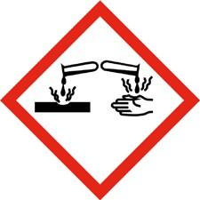
Per OSHA definition, “A corrosive substance is a chemical that produces destruction of skin tissue, namely, visible necrosis through the epidermis and into the dermis.” Consult the chemical SDS documents to determine if it is considered “corrosive”.

 | Supplementary Modules:
• | Working safely with corrosive liquids and solids

Carcinogens
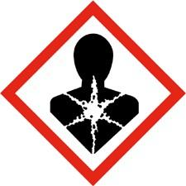
See carcinogen section of this document

Reproductive toxins
See reproductive hazards section of this document

Sensitizers (a.k.a. Allergens)
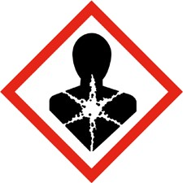
A chemical that causes a substantial proportion of exposed people or animals to develop an allergic reaction in normal tissue after repeated exposure to the chemical. Specifically: Respiratory sensitizer means a chemical that will lead to hypersensitivity of the airways following inhalation of a chemical. Skin sensitizer means a chemical that will lead to an allergic response following skin contact.

Flammables
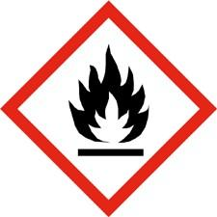
A flammable material is any liquid, solid or gas that will ignite easily and burn rapidly. Materials that are flammable are of concern due to their ability to render damage to property and more importantly, to injure or cause death of workers. Flammable liquid refers to any liquid having a flash point below 93 C (199º F). Flammable liquids need to be stored in a NFPA approved flammable storage cabinet.
 | Supplementary Modules:
• | OSHA 29 CFR 1910.106: Flammable and combustible liquids

Combustible dust
Any combustible material (and some materials normally considered noncombustible) can burn rapidly when in a finely divided form. If such a dust is suspended in air in the right concentration, it can become explosive. The force from such an explosion can cause employee deaths, injuries, and destruction of entire buildings. Materials that may form combustible dust include metals (such as aluminum and magnesium), wood, coal, plastics, biosolids, sugar, paper, soap, dried blood,

and certain textiles.
 | Supplementary Module:
• | Combustible Dust in Industry: Preventing and Mitigating the Effects of Fire and Explosions

Reactive chemicals and chemical reactions

Reactive chemicals
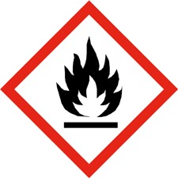
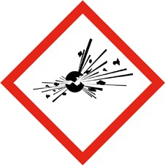
Reactive chemicals are unstable materials or materials that react to heat, shock, friction, catalysts, or by contact with air or water. Air, light, heat, mechanical shock, water, and certain catalysts can cause decomposition of some highly reactive chemicals, liberating heat, or toxic gasses, or leading to an explosion. The following table shows different classes of reactive chemicals:

Reactivity Hazard  General Definition  Examples | Reactivity Hazard General Definition  Examples | Reactivity Hazard General Definition Examples
UNSTABLE:  (Decomposing, Thermally  Sensitive, Shock  Sensitive, Explosive) | Has the tendency to break down (decompose) over time or when exposed to conditions such as heat, sunlight, shock, friction, or a catalyst with the resulting decomposition products often being toxic or flammable. Decomposition can be rapid enough to give an explosive | Trinitrotoluene (TNT), dibenzoyl peroxide, ethylene oxide, acetylene, picric acid, hydrogen peroxide (concentrated)
 | energy release and can generate enough heat and gases for fires/explosions.
POLYMERIZING | Has the tendency to self-react to form larger molecules, while possibly generating enough heat/gases to burst a container | Acrylic acid, styrene, 1,3butadiene
PYROPHORIC | Will ignite spontaneously when exposed to air | White Phosphorus, Silane, Lithium hydride, Grignard reagents, Diborane,
PEROXIDE FORMER | Has the tendency to slowly react with oxygen, such as from being exposed to air, to form unstable organic peroxides | 1,3-Butadiene, isopropyl ether, ethyl ether
WATER REACTIVE | Will react with water or moisture. Some react slowly; others violently. Heat and flammable/toxic gases may be produced. | Sodium, sulfuric acid, acetic anhydride
OXIDIZER | Will give up oxygen easily or readily oxidize other materials. | Chlorine, nitric acid, perchloric acid, Hydrogen peroxide

Chemical reactions (Reactive interactions)
Reactive interactions require the combining of two or more materials to pose a hazardous situation by chemical reaction. Many materials that are not considered “reactive materials” can react dangerously with other incompatible materials. Incompatible materials must be sufficiently segregated in storage to prevent mixing during fires, explosions, and natural disasters like earthquakes. Accidents with incompatible materials often occur during mixing wastes in laboratories.
 | Supplementary Modules:
• | Essential Practices for Managing Chemical Reactivity Hazards
• | OSHA/CCPS Chemical Reactivity Hazard
• | OSHA: Explosive and Blasting Agents

10. Exposure prevention and assessment

Permissible exposure limits
For laboratory use (29 CFR 1910.1450) of OSHA regulated substances, the procedures set forth in this document are intended to control laboratory employees' exposures to levels which do not exceed the permissible exposure limits specified in 29 CFR part 1910, subpart Z.

Exposure Assessment

Initial Monitoring:
Conducted when there is a reason to believe that exposure to hazardous material may reach or exceed occupational exposure limits or action levels, or upon user’s request.

Periodic monitoring:
If the initial monitoring indicates employee exposure over the action level (or in the absence of an action level, the Permissible Exposure Limits (PEL)), the PI / Supervisor shall immediately comply with the exposure monitoring provisions of the relevant standard.

Employee notification of monitoring results
ROEHS shall, within 15 working days after the receipt of any monitoring results, notify the employee of these results in writing either individually or by posting results in an appropriate location that is accessible to employees. JSNN provides medical consultation for employees who may have been exposed to chemicals in excess of OSHA exposure limits.

11. Safety Data Sheet (SDS) and Labels
PI / supervisors shall ensure that labels on incoming containers of hazardous chemicals are not removed or defaced. PIs / Supervisors shall maintain ready access to any safety data sheets that are received with incoming shipments of hazardous chemicals, and ensure that they are readily accessible to laboratory employees. Where chemical purchase is done via electronic access to the vendors catalog, the SDS should also be requested as part of the transaction and the copy received should be retained in the laboratory. Electronic access to SDS is acceptable

12. Hazard reviews

Operations / procedures / activities that require prior approval
Routine lab operations should be conducted according to the practices established in the American Chemical Society Publication "Safety in Academic Chemistry Laboratories". Operations involving new use of hazardous materials and / or equipment require a Hazard Review and need to be approved by the PI / Supervisor and ROEHS

13. Hazard control
Hazard Controls are an important component of the Chemical Hygiene Plan and shall include details of control measures to reduce employee exposure to hazardous chemicals including engineering controls, the use of personal protective equipment and administrative controls / work practices. Particular attention shall be given to the selection of control measures for chemicals that are known to be extremely hazardous. (OSHA regulated chemicals and 13 carcinogens) and as well as systemic toxins and reproductive hazards.
- Elimination
Eliminating the hazard by removing hazardous material from a process

Substitution
Substituting a less hazardous chemical (e.g., using proprietary detergents instead of chromic acid for cleaning glassware or using toluene instead of benzene for liquid-liquid extraction or chromatography) shall be considered when appropriate.

Engineering controls
Engineering control methods include, but are not limited to, isolation, and using exhaust ventilation systems (laboratory chemical hoods, gas cabinets, glove boxes, biosafety cabinets, etc.).

fume hood s and local exhaust devices
The primary purpose of local exhaust ventilation is to protect the employee from hazardous airborne exposures. Before starting the experiment, users need to ensure that fume hoods and other exhaust devices are functioning properly. Users must stop the experiment, close the hood sash, and report any deficiencies and malfunctions to ROEHS. Fume hood users must complete the JSNN fume hood safety training.

Gas cabinets
hazardous gas cylinders must be housed in gas cylinder cabinets.

Glovebox
Pyrophoric, air reactive, and water reactive chemicals are required to be stored and used under inert atmospheric conditions (i.e. a glove box). Any Glove Box shall meet the ANSI Z 9.5-2003 (or most current version) requirements.

Other exhaust devices
Other exhaust devices such as snorkels and canopy hoods have limited applications and are not generally appropriate for hazardous chemical exposure control in laboratories. PIs / Supervisors shall train all employees and students to ensure that they are aware of use and limitations of different exhaust systems in laboratories. d. Administrative control

d) Administrative controls
Procedural measures which should be taken to reduce or eliminate hazards associated with the use of hazardous materials.

e) Personal Protective Equipment (PPE)
Personal protective equipment must be selected based on a hazard evaluation for each process. PPE assessment needs to be documented under the Lab Safety Plan. Minimum PPE for entering the JSNN research labs include eye protection, lab coat, closed-toe shoes, and long pants/dress.
 | Supplementary Module:
• | OSHA General requirements. – 29 CFR 1910.132

14. Chemical Security (DHS)
The Department of Homeland Security (DHS) has issued Chemical Facility Anti-Terrorism Standards for any facility that manufactures, uses, stores, or distributes designated chemicals above a specified quantity. All laboratories shall maintain an updated chemical inventory (as part of their Safety Plan) for both employee information and DHS reporting purposes.. A list of the designated chemicals can be found under Chemicals of Interest.

15. Shipping and transferring chemicals
Shipment and transferring chemicals to/from the JSNN building requires ROEHS notification and approval. Air and ground shipment of hazardous chemicals requires specific training, labeling, and packaging.

16. Particularly Hazardous Substances and Processes

Pressure Vessels
Pressure vessels requiring a hazard review include equipment operating at greater than 15 psig that have a larger internal diameter than the plumbing lines leading to the vessel. are excluded from the requirement for a hazard review. Hazard review requirements apply to new equipment, donated equipment, and pressure vessels fabricated at or for JSNN.

OSHA carcinogens
A carcinogen, as defined by OSHA Lab Safety Standard, is any substance or agent that is capable of causing cancer – the abnormal or uncontrolled growth of new cells in any part of the body in humans or animals. Carcinogens are chronic toxins with long latency periods that can cause damage after repeated or long duration exposures and often do not have immediate apparent harmful effects.
The State of California has developed an extensive list of “Carcinogens Known to the State of California through Prop 65”.
OSHA Carcinogens
2-Acetylaminofluorene (CAS # 53963) | Acrylonitrile (CAS # 107131)
4-Aminodiphenyl (CAS # 92671) | Benzene (CAS # 71-43-2)
Benzidine (CAS # 92875) | 1,3-Butadiene (CAS # 106990)
bis-Chloromethyl ether (CAS # 542881) | 1,2-Dibromo-3-chloropropane (CAS # 96128)
3,3'-Dichlorobenzidine (CAS # 91941) | Ethylene oxide (CAS # 75218)
4-Dimethylaminoazobenzene (CAS # 60117) | Formaldehyde (CAS # 50000)
Ethyleneimine (CAS # 151564) | Methylene chloride (CAS # 75092)
Methyl chloromethyl ether (CAS # 107302) | Methylenedianiline (CAS # 101779)
alpha-Naphthylamine (CAS # 134327) | Vinyl Chloride (CAS # 75014)
beta-Naphthylamine (CAS # 91598) | Asbestos containing materials
4-Nitrobiphenyl (CAS # 92933) | Cadmium containing compounds
N-Nitrosodimethylamine (CAS # 62759) | Chromium (VI) containing compounds
beta-Propiolactone (CAS # 57578) | Inorganic Arsenic containing compounds
- Beryllium
- Lead
- Cotton Dust
- Respirable crystalline silica.

 | Supplementary Module:
• | OSHA Safety and Health Topics for Carcinogens webpage.

Hydrofluoric acid (Hydrogen fluoride, HF)
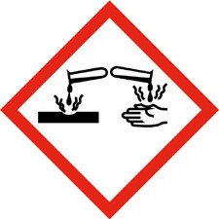
Hydrofluoric Acid (HF) is one of the strongest and most corrosive acids known and is also a poison. Therefore, special safety precautions are necessary when using this chemical. Anyone using HF MUST be trained and have fresh Calcium gluconate gel readily available.

17. Emergency procedures
Any life threatening emergency, fire, or severe exposure will require a 911 call. JSNN emergency procedures define necessary action during emergencies and whenever immediate assistance is needed due to a safety concern. .
See EH&S website for additional information: Emergency Resources

18. Procedures for chemicals developed in the laboratory
PEr OSHA Hazard Communication standard requirements, PIs must perform a hazard assessment and develop SDS document for new chemicals developed in their lab

19. Hazardous Waste
All hazardous waste must be properly collected, labeled, stored, and discarded based on the JSNN hazardous waste program requirements. JSNN does not allow any drain disposal or mixing hazardous waste.

20. Physical hazards

Compressed gases
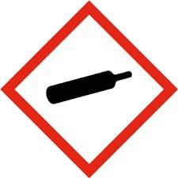
Compressed gas cylinders can present a variety of hazards due to their pressure and /or contents. All hazardous gases purchases must be approved by ROEHS.

Cryogenic hazards
Using and dispensing cryogenic gases requires cryogenic gas safety training. Proper cryogenic gloves, body protection, eye protection, and face protection are the minimum required PPE. Cryogenic liquids shall not be used in aries without proper exhaust ventilation.

class 3b and 4 lasers
Open beams of the class 3b or 4 lasers will require ROEHS review and approval for proper training, interlocks, signage, and PPE.

